Calendar
Fri. March 3, First Friday (Blessed Ashes distributed after all Masses this weekend)
6:00 pm Mass, followed by Rosary and Benediction
Sat. March 4, First Saturday: 9:00 am Mass, Holy Hour of Reparation

Sun. March 5, First Sunday of Lent
7:30 am Low Mass
9:00 am: Catechism
10:00 am Sung Mass
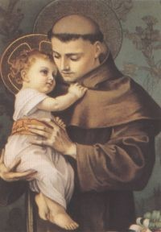
Sat. March 11, 9:00 am Mass, Holy Hour of Reparation

Sun. March 12, Second Sunday of Lent
7:30 am Low Mass (Holy Name Society Mass)
9:00 am: Servers Practice
10:00 am Low Mass

Sat. March 18, 9:00 am Mass, Holy Hour of Reparation

Sunday, March 19, Third Sunday of Lent
7:30 am Low Mass
9:00 am: Catechism
10:00 am Low Mass

Sat. March 25, 9:00 am Mass, Holy Hour of Reparation
Lenten Day of Recollection

Sunday, March 26, Fourth Sunday of Lent (Laetare Sunday)
7:30 am Low Mass
10:00 am SungMass
St. Anthony’s Table Refreshment Sunday
St. Anthony of Padua Church
Directons:
From I-80 (Eastbound):
Exit 47 B (The Caldwells/Montclair) to US 46 E Right on Bloomfield Ave.
Left on Mountain Ave. Left to 103 Gould
From I-80 (Westbound)
Exit 53 to NJ-23S. Right on Lindley Rd. Left on Mountain Ave. Right to 103 Gould
From US-46 (East of Willowbrook Mall):
US-46W to NJ-23S. Right on Lindsley Rd. Left on Mountain Ave. Right to 103 Gould Ave.
From US-46 (West of Willowbrook Mall):
US-46 E to Bloomfield Ave. Right on Bloomfield Ave.
Left to 103 Gould Ave.
Society of St. Pius X
103 Gould Ave. North Caldwell, New Jersey 07006 (973) 228-1230

March, 2017

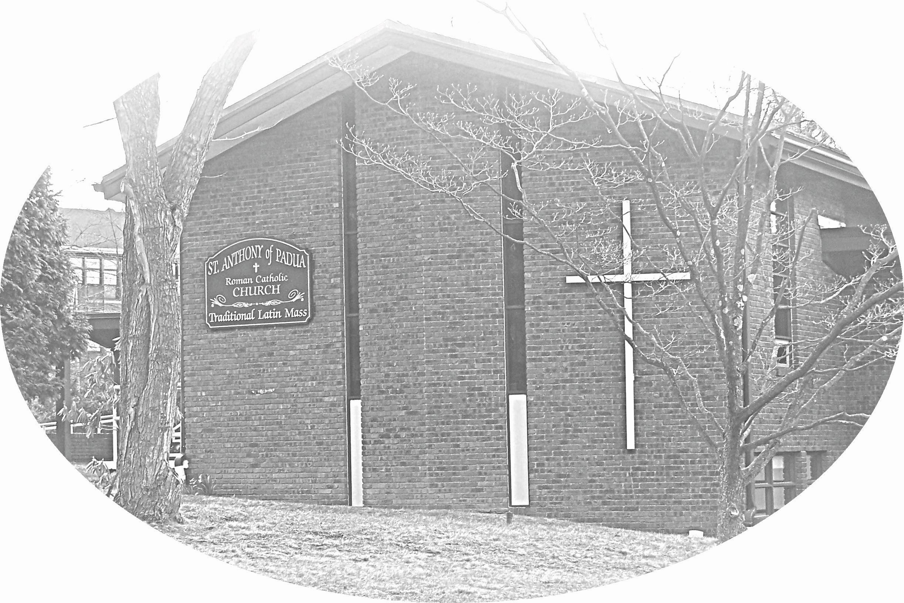

From I-280 (Option 1): Exit 5a or 5b to Livingston Ave. (northbound). Right on Eagle Rock Ave. Left on Roseland Ave. Right on Bloomfield Ave. Left on Mountain Ave. Left to 103 Gould
From I-280 (option 2) Exit 7 to Pleasant Valley Way (northbound). Left on Bloomfield Ave. Right on Mountain Ave. Left to 103 Gould Ave.
From I-287: I-287 to NJ-23 or I-80, whichever is closer. Follow directions as above for NJ-23 southbound or I-80 eastbound
Pastor: Rev. Fr. Carl Sulzen
In residence at: St. Ignatius Retreat House,
209 Tackora Trail, Ridgefield, CT. 06877 Tel.: (203) 431-0201
Mass Schedule
Sunday: 7:30AM & 10:00AM / Holy Days: 10:00AM & 7:30PM
Saturday Mass: 9:00AM / First Friday: 6:00PM
Confession
Confessions are heard prior to every Mass.

Sacraments, Sick Calls, & Pastoral Visits Contact the priest at the Ridgefield retreat house (203) 431-0201 for information regarding Baptism,
Marriage, Confirmation, Sick Calls, and Extreme Unction.
Contact Us:
Parish phone: (973) 228-1230 - Available weekends only.
Web: http://www.sspxridgefield.com/ SSPX: http://sspx.org
Administrative Notes

Bookstore
St. Anthony’s bookstore is open each Sunday. Please consider the chapel a source for your religious books and gifts. Proceeds benefit the parish. Stations of the Cross and Rosary CD's,recorded by Fr. Young and the Padre Pio Academy students.
Digital downloads are availible at: www.padrepioacademy.bandcamp.com

Mass Intentions & Stipends
To have Masses offered for living or deceased persons contact the priest personally. The US District stipend is $20 per request. This is a suggested offering, more can be given. A lesser value can be arranged with the priest.

Donations: Check, Cash, or Online
Checks should be made payable to “St. Anthony of Padua Church-SSPX” Donations by check do not require an envelope. Cash donations please consider using an envelope. Include Name, Address, Date, and Amount. The accountant retains the envelope as a receipt for your tax records.
You may also give online or by downloading the simplegive app. http://my.simplegive.com/ dl/?uid=St.103195

Choir
New voices are always welcome in the choir. Boys and girls are encouraged to offer their voices to the praise of God in the choir. Please contact the choir director if you are interested.

Poor Box (Good Samaritan Fund)
The Good Samaritan Fund is for the relief of the needy in our parish. Donations by cash and check accepted. If you or someone you know is in need of assistance, contact the priest or coordinator in person or via a note in the donation box. Recipients known only to the priest and coordinator. Location - White box to the left as you exit the back of the chapel.

Sunday Catechism Classes
Classes are the first and third Sundays at 9:00am.

Parish Groups
Third Order Carmelites meet each month on First Saturdays following the 9:00am Mass.
The Holy Name Society attends the 7:30 am Mass and meets on the second Sunday each month at 9:00am. New members always welcome.

Volunteers
Please consider signing up for church cleaning.

Retreats
Please refer to www.sspxridgefield.com for the latest information.

Please do not place any literature in the Church without Father's permission.
From Father’s desk

Blessed Ashes
"When the priest puts the holy emblem of penance upon you,
accept in a spirit of submission, the sentence of death, which God
Himself pronounces against you: 'Remember O man, that thou art dust,
and into dust thou shalt return!' Humble yourself, and remember what it
was that brought the punishment of death upon us: man wished to be as a
god and preferred his own will to that of his sovereign Master. Reflect too, on
that long list of sins, which you've added to the sin of your first parents; adore
the mercy of your God Who asks only one death for all these your transgressions."
- Dom Prosper Guéranger, O.S.B

On Fasting and Abstinence
Archbishop Marcel Lefebvre
My dear brethren,
According to an ancient and salutary tradition in the Church, on the occasion of the beginning of Lent, I address these words to you in order to encourage you to enter into this penitential season wholeheartedly, with the dispositions willed by the Church and to accomplish the purpose for which the Church prescribes it. If I look in books from the early part of this century, I find that they indicate three purposes for which the Church has prescribed this penitential time:

First - in order to curb the concupiscence of the flesh;
Then - to facilitate the elevation of our souls toward divine realities;
Finally - to make satisfaction for our sins.
Our Lord gave us the example during His life, here on earth: pray and do penance. However, Our Lord, being free from concupiscence and sin, did penance and made satisfaction for our sins, thus showing us that our penance may be beneficial not only for ourselves but also for others.
Pray and do penance.

Do penance in order to pray better, in order to draw closer to Almighty God.
This is what all the saints have done, and this is that of which all the messages
of the Blessed Virgin remind us. Would we dare to say that this necessity is less important in our day and age than in former times? On the contrary, we can and we must affirm that today, more than ever before, prayer and penance are necessary because everything possible has been done to diminish and denigrate these two fundamental elements of Christian life.

Never before has the world sought to satisfy - without any limit, the disordered
instincts of the flesh, even to the point of the murder of millions of innocent,
unborn children. One would come to believe that society has no other reason for existence except to give the greatest material standard of living to all men in
order that they should not be deprived of material goods. Thus we can see that such a society would be opposed to what the Church prescribes.
In these times, when even Churchmen align themselves with the spirit of this world, we witness the disappearance of prayer and penance - particularly in their character of reparation for sins and obtaining pardon for faults.

